

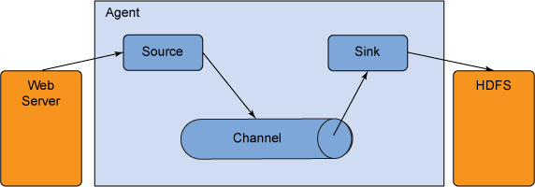



|  |  |  |
| --- | --- | --- |
| **Sources** | **Channels** | **Sinks** |
| • Avro Source  • Thrift Source  • Exec Source  • JMS Source  • Spooling Directory Source  • Twitter 1% firehose Source  • Kafka Source  • NetCat Source  • Sequence Generator Source  • Syslog Sources  • Syslog TCP Source | • Memory Channel  • JDBC Channel  • Kafka Channel  • File Channel  • Spillable Memory Channel  • Pseudo Transaction Channel | • HDFS Sink  • Hive Sink  • Logger Sink  • Avro Sink  • Thrift Sink  • IRC Sink  • File Roll Sink  • Null Sink  • HBaseSink  • AsyncHBaseSink  • MorphlineSolrSink  • ElasticSearchSink |